Make a prompt for a NES 64bit style adventurer "STORYLINE WILL BE” (like Zelda and Pokémon Emerald) a platformer game "GAME PLAY STYLE will be" (like Super Mario Brothers and Calvaina).

The name of the game: “Purr-Fit”.

The game is to be about:
”A BOY or GIRL” (depending on the player's choice) that is trying to earn their first pet.

How to play the game:
”By completing the levels they earn the skills and knowledge (achievements and rewards) that goes with having a pet”. (like care and grooming, feeding, and potty training and walking the pet).

Levels:
“Each one should be their own stage or level. As they progress through each level they morph into their pet. the game should have five levels”.

Level layout and Design:
“the first three will be about:
((((gaining the skills and knowledge and the morphing into the pet
for character building),
the fourth is about:
((using the skills and knowledge to precure the pet from no kill shelters and be aimed at adopting the pet that they morphed into and the process of adoption)). The fifth and final level will be about:
(((the kid and the pet proposing a union and adopting the pet, the parent is to ask questions referring to the cost of having the pet, how the pet will be taken care of, and why they deserve a pet))).”

The end of the game will be:
((((A seen the family and pet becoming one with each other)))).

Gameplay Mechanics:Adventure & Story:

“Inspired by “Zelda and Pokémon Emerald”, the game unfolds in a semi-open world where Max explores different environments tailored to pet care”.

Platforming AND MOVEMENT:

“Borrowing from Super Mario Bros. and Castlevania, each level features precise jumping, item collection”
JUMP: = “Spacebar” (used to leap over obstacles)
MOVE FOWORAD: = “Right Directional Pad or Right Click on Mouse”
MOVE BACKWORDS: = “Left Directional Pad or Left Click on Mouse”
PAUSE: = “SHIFT Key”

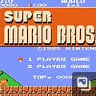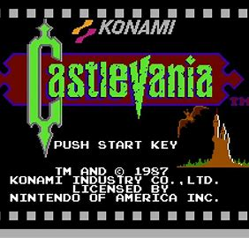
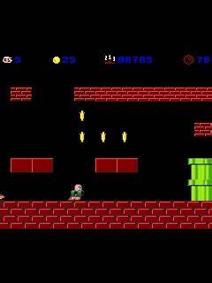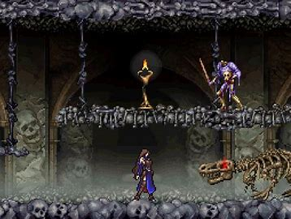

Title: Purr-Fit

Prompt:
In the charming yet mysterious world of Petropolis, a young boy or girl (depending on the player’s choice) embarks on a heartfelt journey to prove they are ready for their first pet. Guided by the mystical Petkeeper, they must complete five trials, each designed to teach them the responsibilities of pet care. As they progress, they begin to morph into their chosen pet, embodying its spirit and abilities to fully understand its needs.

Gameplay Mechanics:

Adventure & Story:
- Inspired by Zelda and Pokémon Emerald, the game unfolds in a semi-open world where players explore different environments tailored to pet care.
- Dialogue-driven interactions with NPCs provide guidance, challenges, and lessons about responsible pet ownership.

Platforming & Movement:
- Borrowing from Super Mario Bros. and Castlevania, each level features precise jumping, item collection, and minor environmental hazards.
- Controls:
  - Jump → Spacebar (Used to leap over obstacles)
  - Move Forward → Right Directional Pad or Right Mouse Click
  - Move Backward → Left Directional Pad or Left Mouse Click
  - Pause → Shift Key

Levels & Transformation:

Level 1: Feeding Frenzy 🍖
- Objective: Learn how to properly feed a pet.
- Gameplay: Navigate bustling food markets, gather healthy ingredients, and dodge mischievous critters trying to steal food.
- Transformation: The player’s ears start changing, becoming more animal-like.

Level 2: Groom & Bloom 🛁
- Objective: Understand grooming needs for different pets.
- Gameplay: Solve puzzles using different grooming tools, avoiding hazards like slippery soap spills and tangled fur.
- Transformation: The player’s fur, feathers, or scales begin to grow, reflecting their chosen pet.

Level 3: Walk the Paw-th 🚶‍♂️
- Objective: Master walking and exercising a pet.
- Gameplay: Navigate tricky terrain (parks, busy sidewalks, obstacle courses), learning movement behaviors unique to dogs, cats, and birds.
- Transformation: The player's full body starts to shift, resembling their chosen pet.

Level 4: Rescue Mission 🏡
- Objective: Understand adoption and rescuing pets from no-kill shelters.
- Gameplay: Visit different shelters, interact with pets in need, and use acquired skills to ensure the pet’s well-being before adoption.
- Transformation: The player is fully their chosen pet, symbolizing their readiness.

Level 5: The Final Test 💖
- Objective: Convince the parent they are prepared for pet ownership.
- Gameplay: Answer questions about pet care, budgeting, and responsibility while navigating an interactive dialogue system.
- Outcome: The player regains their human form, proving their readiness, and adopts the pet. The final scene showcases the player, their pet, and family coming together as one.

Endgame & Replayability:
- Unlock different pet types (dogs, cats, birds) with unique abilities.
- Multiple shelters and pet personalities for varied adoption experiences.
- Post-game activities: Training mini-games, playing fetch, bonding events.

This blend of platforming action and educational storytelling makes Purr-Fit a unique and engaging adventure! Does this align with your vision? Let’s refine anything further! 🐾✨

